LISTENING UNIT 3: MONEY
- THEORY
British money has pound (£) and pence (p). 1 pound = 100 pence.
£ is written before the number, but it is said after the number.
£1 a/one pound
£20 twenty pounds
£100 alone hundred pounds
p is written after the number and said after it.
50p fifty pence
76p seventy-six pence
A sum of money can be said in different ways:
£10.50 1. ten pounds fifty pence
2. ten pounds fifty
3. ten fifty
£21.99 1. twenty-one pounds ninety-nine pence
2. twenty-one pounds ninety-nine
3. twenty-one ninety-nine pounds

$: dollar
$21.99: twenty-one ninety-nine dollars
Nếu như phía trước có ký hiệu về currency rồi ($, £), chỉ cần điền số ở phía sau
Nếu như phía trước không có ký hiệu về currency ($, £), ngoài viết số thì cần viết đơn vị tiền tệ (21.99 dollars/pounds)

1. Types of money or card  Money: tiền (nói chung)  Coin: đồng xu  Cash: tiền mặt  Banknotes/ paper money: tiền giấy  Debit card: thẻ ghi nợ  Credit card: thẻ tín dụng  Prepaid card: thẻ trả trước  Bank account: tài khoản ngân hàng  Cheque: séc  Visa/ master card: thẻ thanh toán quốc tế | 2. Payment Method  Mode of payment: phương thức thanh toán  Direct payment: thanh toán trực tiếp  Pay on Internet: thanh toán qua mạng  Pay by card: thanh toán bằng thẻ  Pay by cheque: trả bằng séc  Receipt: biên lai, hóa đơn khi mua hàng  Bill: hóa đơn  Price: giá cả  Ticket: vé  Customer: khách hàng  Pay in cash: trả bằng tiền mặt  pay by card: trả bằng thẻ  debit card: thẻ ghi có  credit card: thẻ tín dụng  pay by check/cheque  deposit: tiền đặt cọc  balance: tiền còn lại phải trả
- PRACTICE
Ex1. (CD 14) Listen to the recording and write down the price for each item
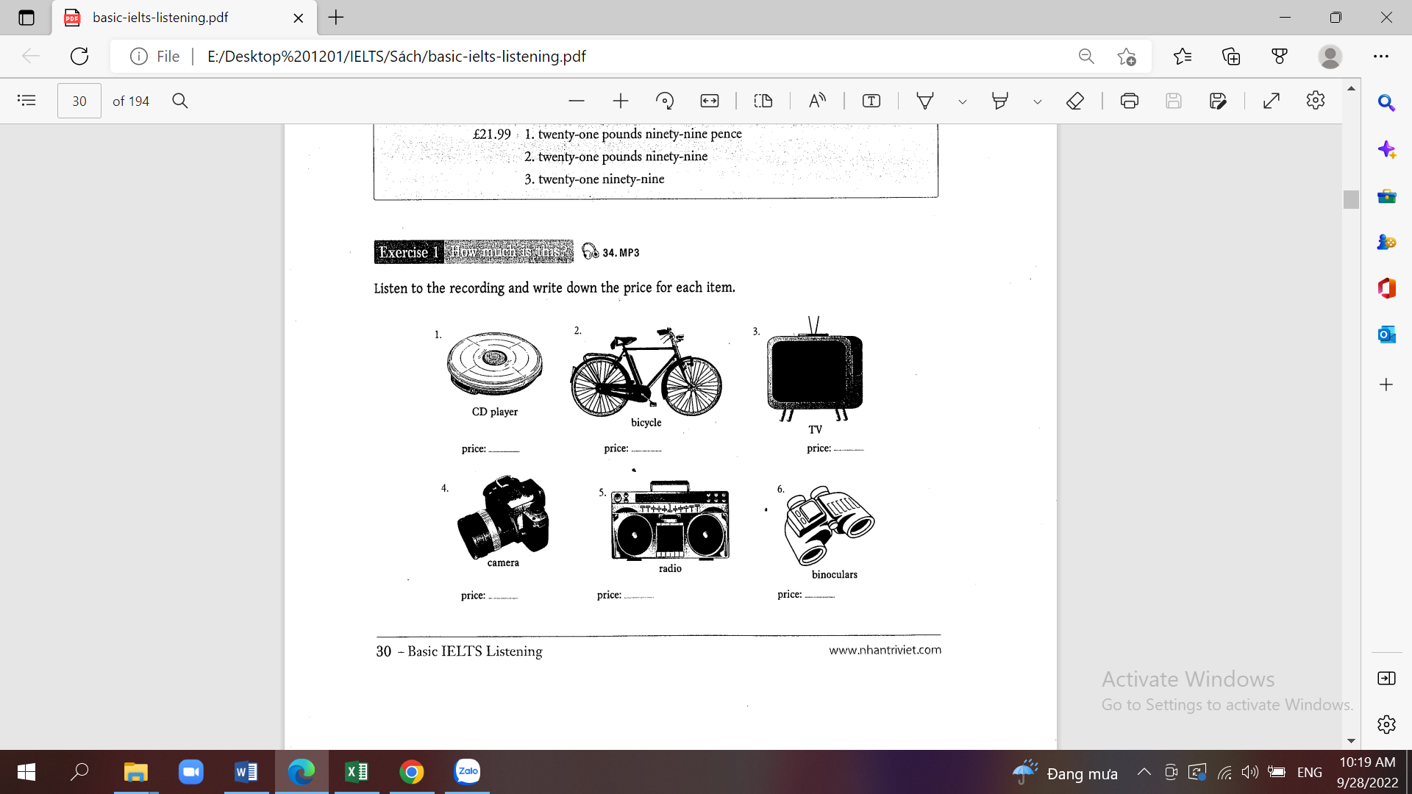
      - 120
      - 90
      - 269
      - 199
      - 49
      - 69
Ex2 (CD15) Listen to the recording and write down the prices (in figures)
- How much does this cost, please?
- What's the price of that book, please?
- How much are those shoes, please?
- How much is that, please?
- How much is the bill, please?
- Can you tell me how much is left in my bank account, please?
- How much will it cost to send this letter to France?
- What's the price of that bike over there?
- How much is the return ticket to Edinburgh?
- How much does this cost, please?
      - 25
      - 18.50
      - 30
      - 40
      - 90.50
      - 300.35 x 335
      - 0.35 x 0.5 fifty
      - 100.25 x 125
      - 17.30 x17.40
      - 0.60

Ex3 (CD16) Listen to the talk and write down the prices in the boxes provided

Transport | Price
Bus fare (minimum) | 0.40
Underground fare (minimum) | 0.50
Taxi fare (minimum) | 2
Coach fare | 1.20

- SELF-PRACTICE
Ex1. (CD17) Listen to the second part of the talk and write down the prices in the boxes

Living | Price
Rent for one room | 40
Rent for one-bedroom flat | 200
A local telephone call | 0.50
Posting a letter | 0.40
A bottle of beer | 1.50
Use of a large washing machine | 2.50
Use of a small washing machine | 1.80
Use of a tumble drier | 1.50
Washing powder (a medium-sized packet) | 2.40

Ex2 (CD18) Listen to the last part of the talk and write down the prices in the boxes

Clothes | Price
A shirt | 12
A jacket | 45
A pair of jeans | 25
A pair of running shoes | 30 x 35
A warm coat | 50
A light raincoat | 39
A skirt | 23
A day dress | 49

